**Name: Hamza Mehmood Mughal**

**Intern ID: TN/IN02/PY/009**

**Task no:** **10**

**Question: Store three coordinates and unpack**

**Swap variables using tuple assignment**

Code:

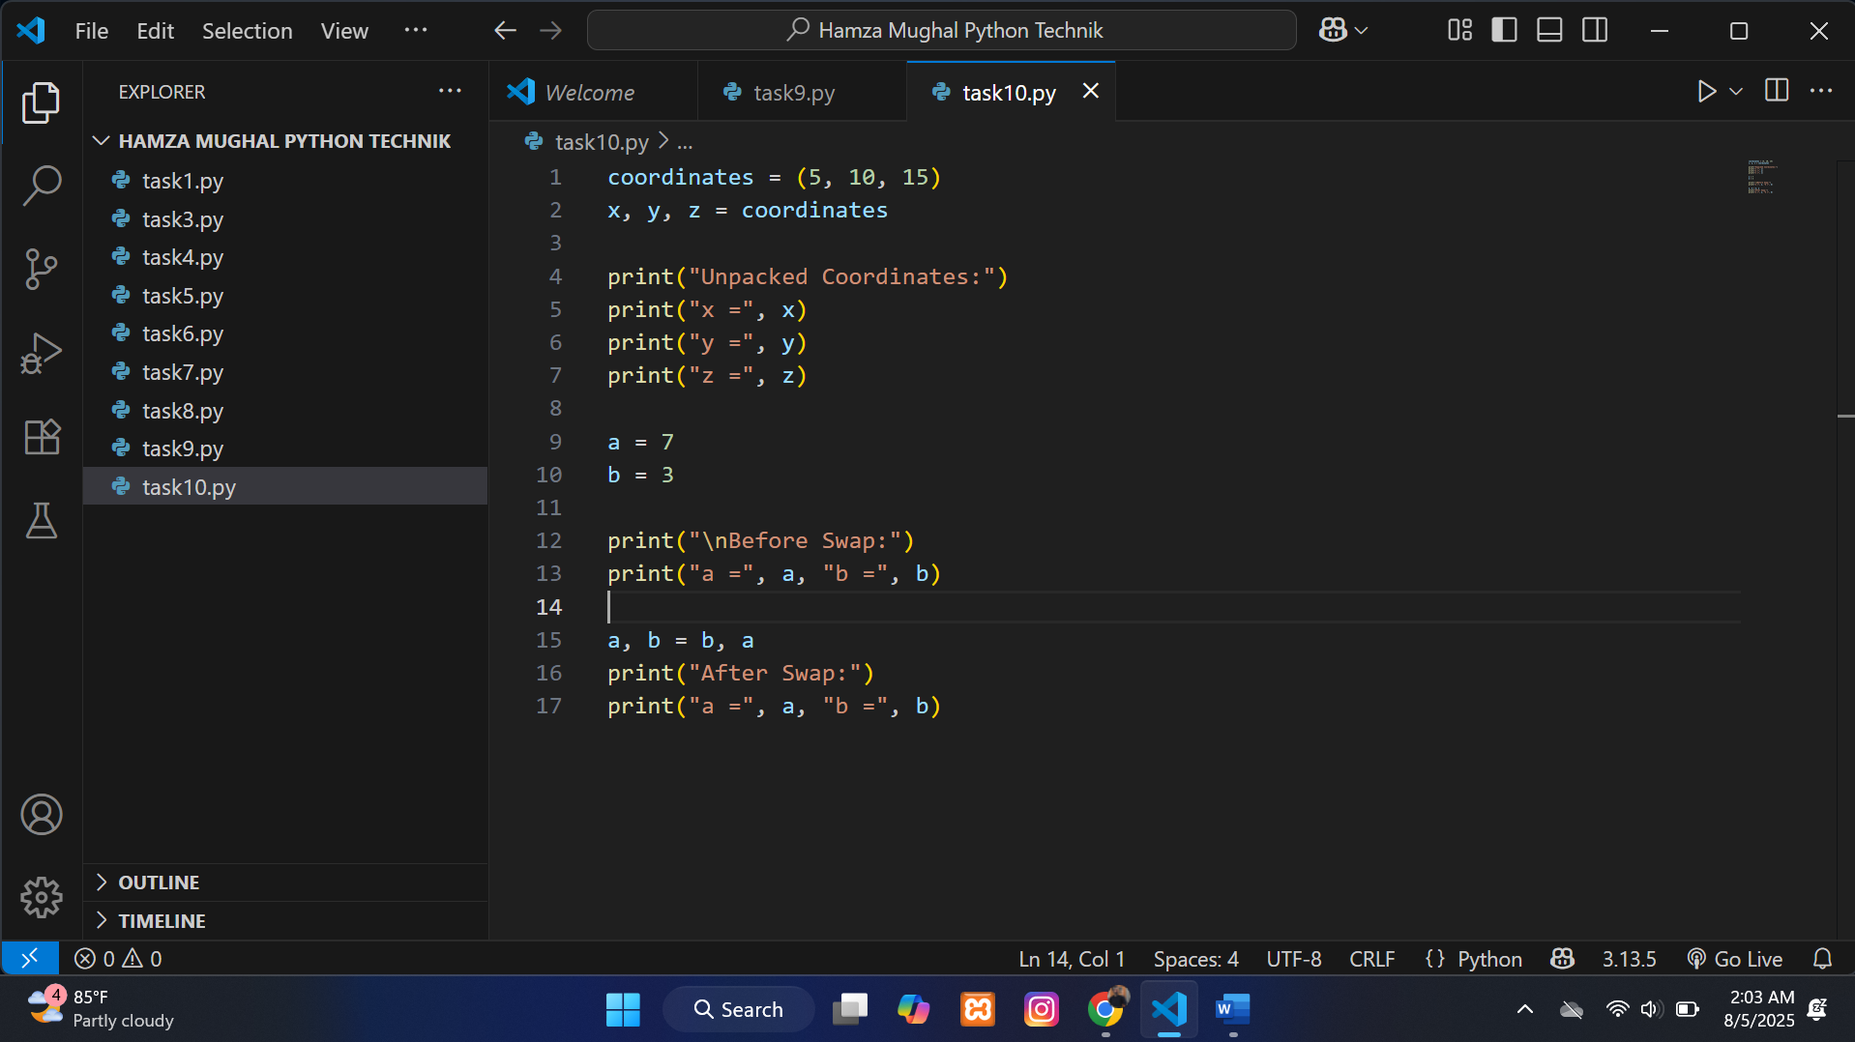

**Output:**

